

*Organisation: Solar Boat Sealander*

*Client: Mr. R. Eijlers*

*Tutor: Mr. W. Haak*

*Date: 1-10-2020*

Demo test plan

Propulsion system simulation

Fangzhou chen Jiacong li Marco Hoogesteger Martijn Crombeen

2020

Table of content

1. Aim & Hypothesis 2

1.1. Aim 2

1.2. Hypothesis 2

2. Variables 2

2.1. Common situation 2

2.2. Unusual situation 2

2.3. Outputs 2

3. Tools 3

4. Method 3

4.1. Steps 3

5. Expected results 4

6. Conclusion 4

# Aim & Hypothesis

## Aim

The aim of this test is to let the client use the simulation interface to calculate different aspects of the propulsion system.

## Hypothesis

The client can use this validated simulation to design an improved the propulsion system.

# Variables

These are the constants and variables that will be used during the test. The constants are the same for both situations and define the testing environment.

We will be testing two situations to check the borders of the system. The first situation is a situation were normal values will be put in, between the stated limits. For the second situation we stress the system a bit and put in exceptional values and show how the simulation will react on that.

|  |  |
| --- | --- |
| Constants | Keep constant at... |
| Ambient temperature | Standard indoor temperature with lower and upper limits (20 ℃ ± 5℃). |
| Battery level computer | Constant power source. |
| Software Excel | Newest version. |
| All input variables | Real positive numbers & ISO-notation. |

## Common situation

The limits stated are the limits of the real world. If values are put in out of this range, the outputs will be unreliable.

|  |  |
| --- | --- |
| Inputs | Value |
| Motor input rotation speed [rpm] | Change value between 600 & 3000 |
| Motor input torque [Nm] | Change value between 6 & 30 |
| Propeller blade count [#] | Change value between 2 & 6 |
| Propeller size (diameter) [m] | Change value between 0,1 & 0,5 |

## Unusual situation

|  |  |
| --- | --- |
| Inputs | Value |
| Motor input rotation speed [rpm] | Input the letter ‘h’ |
| Motor input torque [Nm] | -100.000 |
| Propeller blade count [#] | 0 |
| Propeller size (diameter) [m] | 200 |

## Outputs

The outputs monitored will be the same for both situations and will be used to see variations or changes in the system.

|  |  |
| --- | --- |
| Outputs | Value |
| Thrust [N] | Indicator between 10 & 500 |
| Total power loss [% of $P_{in}$] | Indicator between 5% & 30% |

# Tools

Below are the tools listed that will be used during this test.

|  |  |
| --- | --- |
| Testing tools | Demand |
| Computer | Windows 10 compatible |
| Excel | Newest version. |
| Keyboard | No limit. |
| Mouse | No limit. |

# Method

This section consists of actions that need to be performed during the test in order to conclude a result. The conditions of the constants stated in chapter “2. Variables” have to be met before executing the simulation. To execute the simulation, follow the steps stated in “4.1. Steps”.

To validate our design, we first simulate the current propulsion system and measure the real values of the prototyping setup. We then compare the measured values to the simulation outputs and improve the simulation so that the calculated values are within an error margin of the measured values. When this is the case for all the measurements, we can state that the calculation chain is validated.

We will make a video of the measured values of our prototyping setup and film a laptop screen, where the same values will be the output of the simulation. This video will be shown together with the demonstration.

In case the boat is not available for testing, we will perform the same steps and calculations, only the simulation will not be validated yet.

## Steps

1. Power up the laptop and open Microsoft Excel.
2. Load in the: “Propulsion system simulation” file in Excel.
3. Modify the value of the different inputs.
4. Perform a simulation for every input value modification.
5. Compare the results of the simulations before and after the modifications to figure out their effects on the propulsion system.
6. Note the values which improve the propulsion system.
7. Print improved values.
8. Save changes to new file.
9. Close Excel.

# Expected results

The expected results of the outputs are as followed.

For the output thrust, we expect the value to be between 10 and 500 [N].

For the total power loss, we expect the value to be between 5% and 30% of the input power.

We expect that the simulation works properly.

When the inputs are like stated at “2.2 Unusual situation”, so for example wrong notations or letters, the simulation won’t give any output values.

# Conclusion

When the input values are being changed within the given range, the output values are changing accordingly. We then consider the test as reliable and passed.

When the inputs are out of the given range but by no more than 10% of the range, the expected output values will be beyond the value range stated above. Then the output is considered as unreliable but the simulation is still working, so we consider that it passes the test.

When the inputs are like stated at “2.2 Unusual situation” (out of range by more than 10% or incorrect values) and the system does give any warnings, we consider that it passes the test.

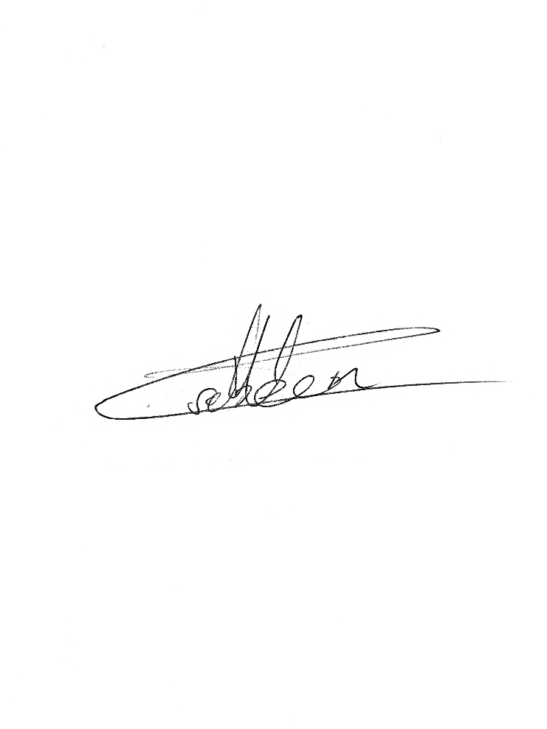

Signed by group 1 Signed by Mr. Eijlers

Date: 5-10-2020 Date: